

g-Pet Technical Update

Please note: It is important that the following procedure is carried out to ensure the accuracy of glucose results when performing tests using the Woodley g-Pet animal validated glucometer. The test strip has a confirmation window situated just above the blood sample target area (see diagram below). This window is used to confirm that enough blood has been drawn into the strip during the testing procedure (1.5µl). Please visually inspect the sample confirmation window to ensure that the appropriate amount of blood volume has been aspirated during testing. This is particularly important when testing blood from a marginal ear vein using a lancing device. If an unexpected low result is reported please recheck the confirmation window.

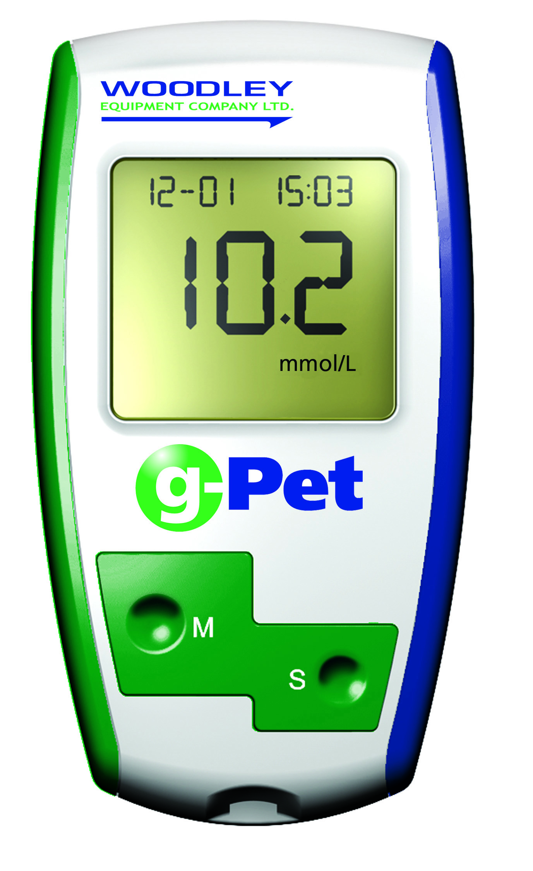
g-Pet Test Strip

1. Contact Bar This end of the g-pet test strip is inserted into the Test Port to activate the g-pet Meter (white side face up, arrow points into test port).

2. Target Area—This is where blood is drawn into the g-pet Test Strip.

3. Confirmation Window—This is where you confirm that enough blood has been applied to the target area.

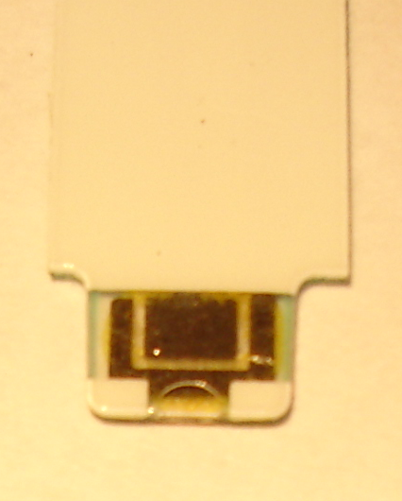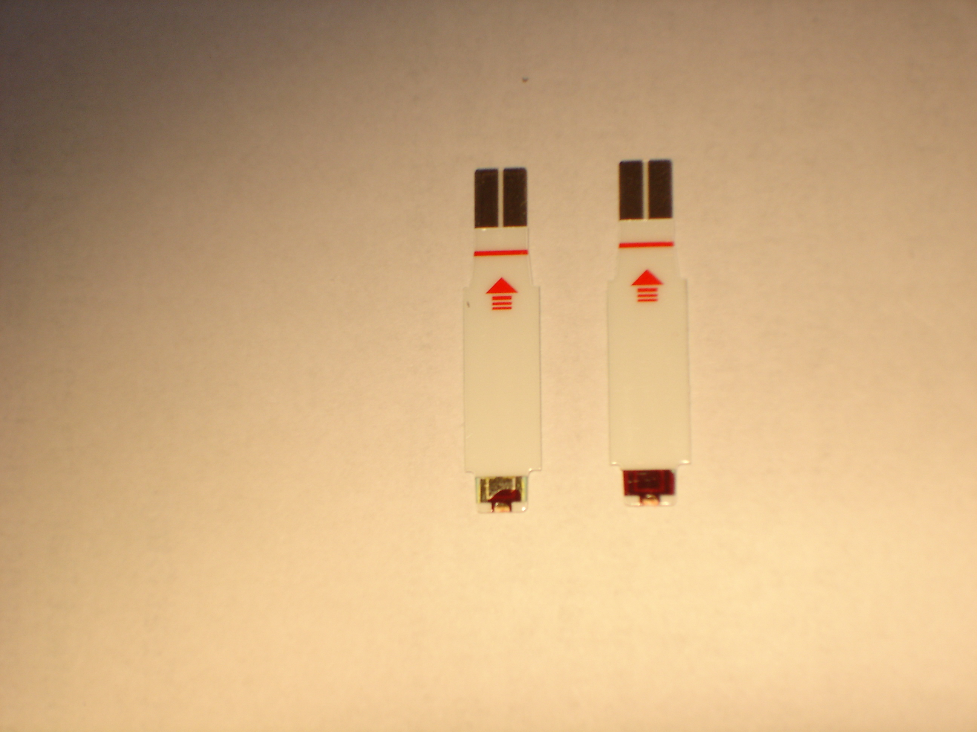
Insufficient Sample Volume
Correct Sample Volume
Empty Strip

If you have any questions please contact Woodley Equipment Company Technical Support Dept. on: +44 (0) 1204 669033 option 1 (UK), +1 (508) 625 1692 (US)


